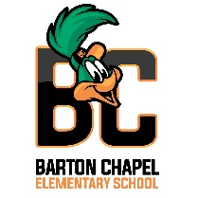 **Hello Parents!

I am Dr. Freeman, your child's 3rd grade Homeroom, Math, and Science teacher at Barton Chapel Elementary School for the 2022-2023 school year and I am super excited to work with your son/daughter this year! We are off to a great start and there is no stopping us now! I have high expectations for our scholars, and being a veteran educator for over twenty years, I know together with we can and we will accomplish and exceed our goals as a class, grade level, and school.

A few quick reminders:

* Class Dojo will be my first line of communication; however, if you need to contact me, my email is:

**robindi@richmond.k12.ga.us.**

* Math & Science Homework will be assigned Monday-Thursday’s. Tests on Friday’s, and I ask that each child commit to 20-30 minutes of i-Ready Math on weekends. Please check Class Dojo and your child’s Agenda nightly for assignments and important messages. (Initial nightly)
* My planning time is 12:00-12:40 pm.

I look forward to having an awesome school year! Again, welcome and thank you for being a part of the Barton Chapel Family!

Thank you,

Dr. Dianesha Robinson-Freeman

3rd Grade Math & Science Teacher

Barton Chapel Elementary School

*P.S. Our school theme this year is -* ***G.A.M.E.S.*** *- Goals and Motivation Equals Success!*